Allez! Allez! Allez!
35 Years of Inspired Cycling!
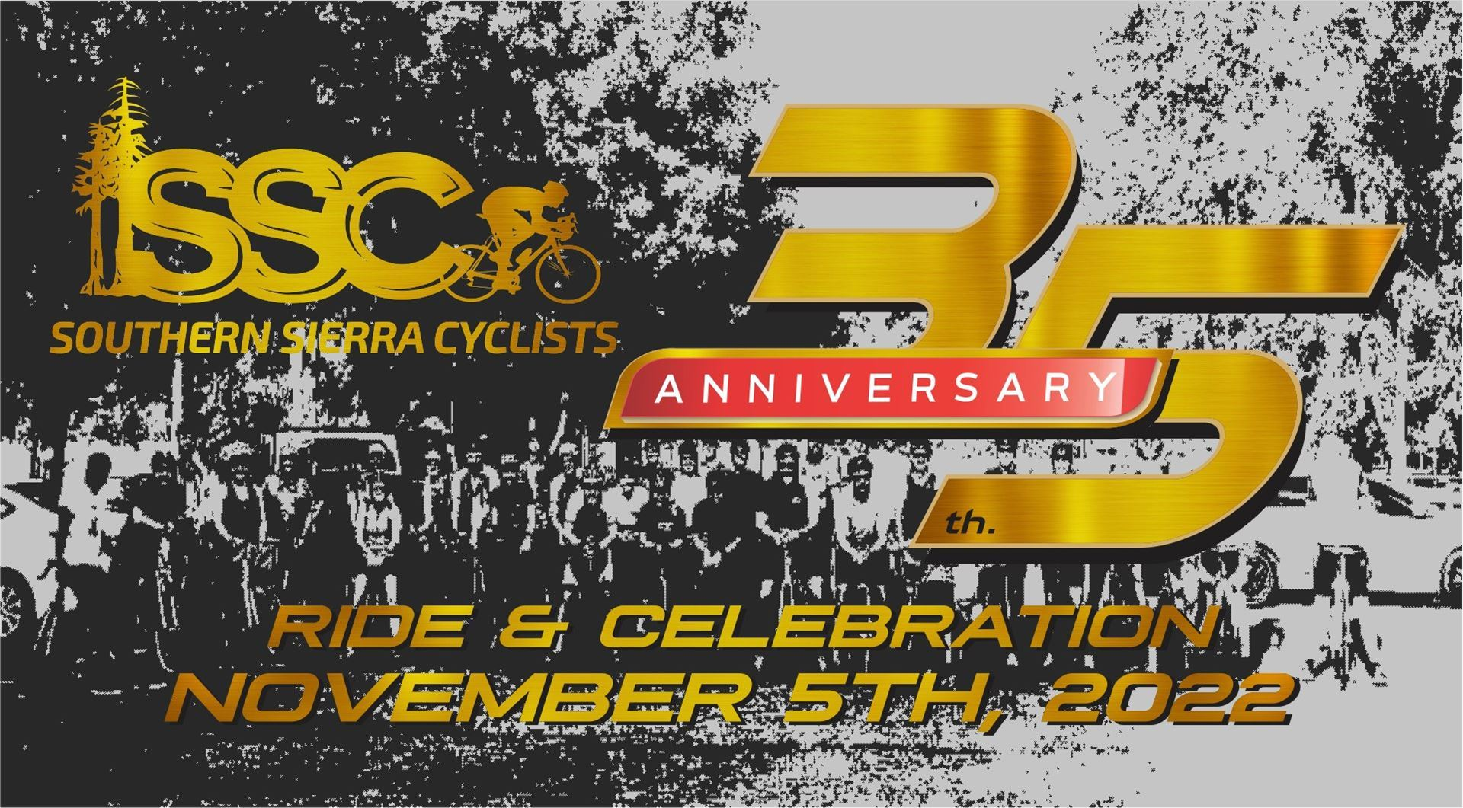
This special edition of Allez! Allez! Allez! is all about what inspired us all to ride our bikes over the past 35 years. I know we haven't all been riding for 35 years but its the inspiration we each found from the first time out to our most recent ride that we all share in common. Over the years SSC has enjoyed, shared and promoted those things that inspire us to ride. And this is true for the lifetime racing champions as well as those who are just getting started. Join with us as we pause to reflect on where that magic came from and ponder where it's headed next.

Foundations
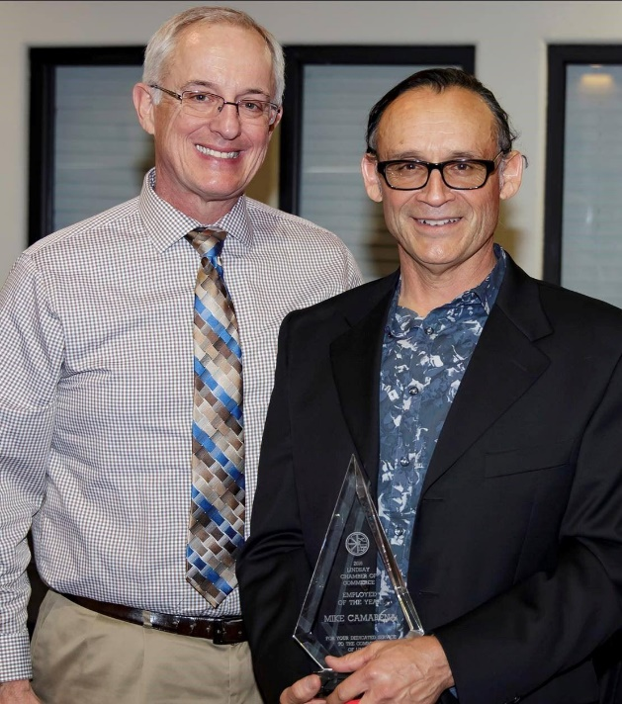
Thinking about inspired cycling and sharing that inspiration with others, there are a few SSC members who come to mind. But there are two who totally exemplify that spirit among us. Mike Camarena and Bill Zigler have been such a huge source of inspiration for so many cyclists over the years and they both continue to do so. It's who they are. The Southern Sierra Cyclists club would not be what it is today without the influence of these two men. So let's take a moment to acknowledge these two giants in our community.
I've often heard it said that if you ride with either of these men you will learn something... each and every time you ride with them. And that's without either of them teaching a course or telling you how it should be done, but simply riding with them. They may offer advice if asked or if they see a dire need but mostly they will just ride. Their knowledge, experience and enthusiasm for the sport are contagious. So if you get the chance to ride with them, take it.
Mike is credited with starting SSC. At the time there was a growing interest in cycling in our area, at least partly due to the successes of Greg Lemond. Craig Wight recalls two junior clubs, the Mt Whitney Cycling Club and the Visalia Cycling Club which had formed but were short lived. As interest grew, the need for a well organized cycling club and race team was filled by the creation of the Southern Sierra Cyclists. The early days of SSC were primarily about racing. And race they did! Without revealing too much detail (come to the 35th Anniversary Celebration for the whole story), the SSC race teams succeeded wildly. Team members raced and won up and down the state, across the nation and even joined the world stage in Europe.
The dedication and work required to reach those heights did not happen by accident. Mike was the team captain and his enthusiasm for cycling as a team sport catalyzed a group of riders, men and women, to ride as a team so that their team could put their rider across the finish line in first. Mike, as a racer, embodied that concept by filling the role of a support rider, which is crucial for winning. The support riders provide and create the environment that will best enable their team to finish in first.
This team concept was embodied by a team that secured sponsorship and support which allowed them to wear matching kits, ride matching team bikes, and present themselves as a team to contend with on race day, which was not common at that time. Mike continues to embrace and inspire cycling races and riding. He is a USAC licensed official helping to officiate races year after year. He organizes rides and inspires riders to become better all the time. Both Mike and Bill were heavily involved with the Active Transportation Committee of the Tulare County Association of Governments and both served as chairpersons of this committee at some point.
Bill Zigler was retired from military service, then graduated from Fresno State before becoming an intern at the City of Lindsay. He later went on to become the City Manager. He and Mike lived near each other in Porterville and commuted to Lindsay every day by bike. (As did Becki Eaton who was a nurse in Lindsay and an SSC race team member who still lives between Porterville and Springville.) Mike was the Public Works Director.
Bill supported cycling races in a big way for a long time, including two editions of the Tour of California and many other big races. But he saw a need in the cycling community for the everyman of our towns and cities to be able to ride and to see riding as a viable mode of transportation, recreation and healthy fun. His involvement with the club became the vehicle by which he and all the club members could help make that happen. It was his enthusiasm and passion for cycling that helped mold the club into what it is today. Continuous acts of charity, outreach and advocacy became the expression of the Southern Sierra Cyclists. Many, many thousands of dollars were raised to help get people on bikes and to make cycling safer. Most of the "Share the Road" signs we see today are there because of these efforts.
There is much much more to hear about SSC history but we look forward to hearing it in person at the 35th Anniversary Celebration next Saturday, November 5th at 5 pm. Please register your intention to come here.

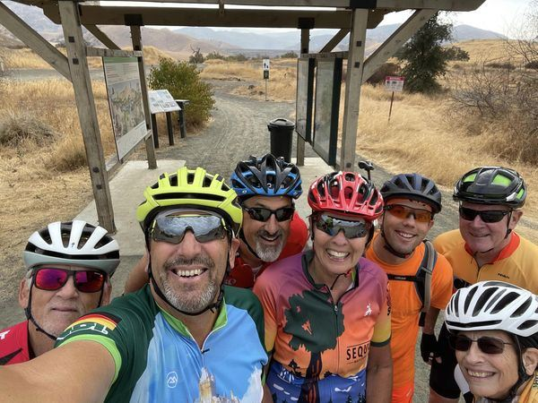
Climate Rise Ride for Sequoia Riverlands Trust
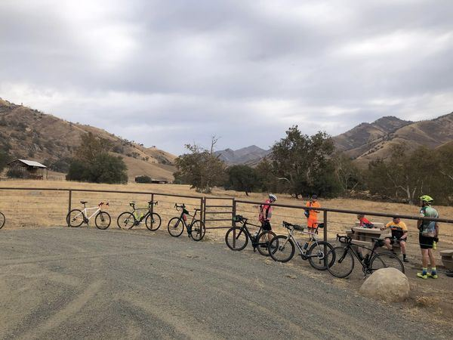
On Saturday, October 22, a Southern Sierra Cyclists team participated in a Climate Rise event to benefit Sequoia Riverlands Trust. The ride started at Kaweah Oaks Preserve, and continued via Lort Drive to Lemon Cove, Dry Creek Preserve, and Homer Ranch Preserve, then completing a loop through Woodlake and Charter Oak Drive back to Kaweah Oaks. So far, the ride has raised $2,985 for Sequoia Riverlands Trust! You can still donate, until December 1, by going to ClimateRide.org, clicking on DONATE in the upper right corner, then entering Southern Sierra Cyclists in the search box. Mark Wall organized the ride, and was joined by SSC members Matt Ely, Janet Lynch, Lonnie Miller, and Paul and Sue Schwartz.
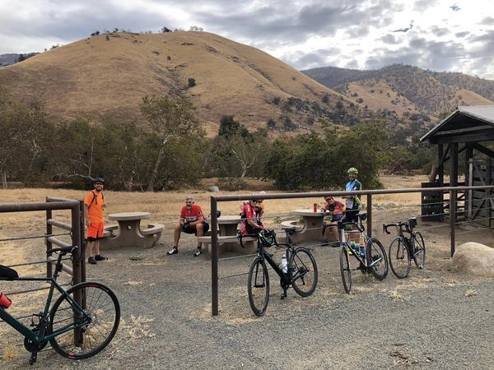

CYCLING SAFETY
As you should know, the mission of our Club is to promote safe bicycling. We do this by setting an example by the way we ride. Club members are committed to riding safely and legally. When riding on the streets of our community, that means:
- stop for Red lights and Stop signs,
- take the lane when it is too narrow to share (when safe),
- when practical, move to the right to allow motorists to pass,
- point out hazards in the roadway to riders behind us, and
- say “On your left” when passing slower riders.
Know your ride limits! If you’re a “B” rider (12-15 mph) with a 30-mile limit, it’s not prudent to join a C/D ride that will drop you as they will be doing 16-20+ mph with a range of 50 -75 miles.
Always think safety when riding. Often, riders in groups want to chat while riding and they allow themselves to ride two or three abreast on the shoulder - this is dangerous, and it can be intimidating to approaching vehicles. It is also dangerous for fellow riders as it makes it difficult to swerve to avoid an object in the roadway.
The disadvantage for cyclists when riding on the roadways is that we don’t have a 4,000-pound shell surrounding us for protection. It is therefore imperative that we always remain vigilant for objects in the roadway, approaching vehicles and anything that would cause us harm.
One thing is for sure: no matter how hard we try, I doubt we can ever be good enough as a group of cyclists to change the perceptions that motorists have about cyclists. Motorists tend to lump all bicycle riders together, and when one cyclist is perceived as bad, then we are all bad. It’s funny it doesn’t work that way for motorists, when one motorist runs a red light or stop sign, they don’t say all motorists are red light or stop sign runners like they do with bicyclists. We must keep working at presenting a positive image of bicyclists and continue to do our Advocacy work to help design traffic infrastructures that are safer for all vehicles, whether a bicycle or motor vehicle.
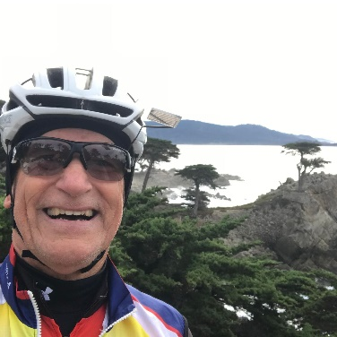
Be Safe! Ride Safe and ride Legal.

This excellent message about cycling safety is being republished from our big brother cycling club at FCC with permission from our good friend 'The Prez', Dennis Ball. Thank you Dennis for sharing such a well written and appropriate message for us all!
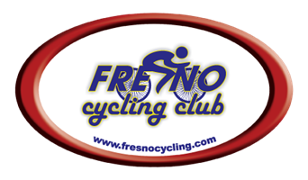

Snippets of the Past
Below are a few interesting excerpts of SSC meetings and newsletters from years past. It shows how the club literally donated it funds to charitable causes, donated their efforts to support the community, and it shows how club members have always loved to ride.
From the October 2008 SSC Monthly Meeting Minutes:
There were 49 paid riders on the Fall Festival Ride. The net profit was $824.98. A motion was made to increase our donation to the Boys and Girls Club of the Sequoias to $1200.00 with SSC club funds making up the difference. M: R. Clyburne, S: J. Mercer. Passed.
From the December 2010 SSC Bike Club Minutes:
- Homeless Connect Day Update: Jim Barnes presented.
  - This annual event makes a significant difference in the lives of the homeless. Many services are provided.
  - Jim B, Kelly, Roy, and Dave Freitas repaired 49 bikes.
  - Well done to these fine men!
From the December 2014 SSC newsletter:
2014 has also been a year for great and epic rides shared by SSC Club members. Members have tested themselves and shared stories of completing centuries, double centuries, the Climb to Kaiser, Grizzly, Lighthouse, and Wildflower annual events, Gran Fondos, and yes; even our favorite 20 mile social ride to Super Taco in Woodlake (BTW, we’re due for another Taco ride). Some have achieved goals such as conquering Rocky Hill or pedaling to their neighboring town, while others have pursued personal improvement goals, such as weight loss, general fitness and lowering blood pressure.
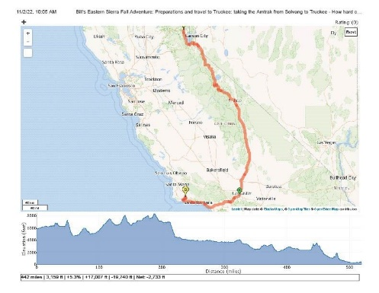
Inspired Cycling along the Eastern Sierras
Bill Zigler is well known for his touring over the years. He usually tours with friends, most notably Roy Clyburne. And often with many other friends he has made and inspired along the way. But this trip he made solo on his trusty "Clown Bike", a folding bike that could be stowed like regular luggage on the train ride to his starting point.

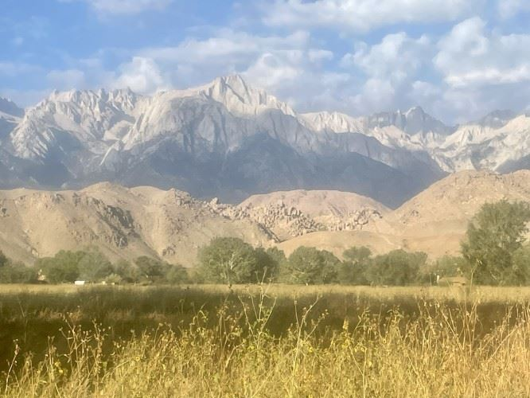
Seeing Bill venture out on his own on a folding bike with a plan to ride from Carson City down the eastern Sierras all the way back to his home in Solvang was more than enough to capture my attention when I saw his first Strava activity from the trip!
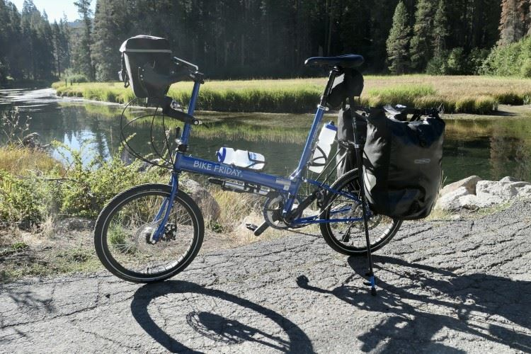
My mind went blank at the first mention of "The Clown Bike". And seeing it pictured "waiting patiently" for him at a rest stop along his route made me wonder even more about both the bike and its rider. But this image fulfilled his notion and explanation of what it was and why he chose to ride "The Clown Bike".
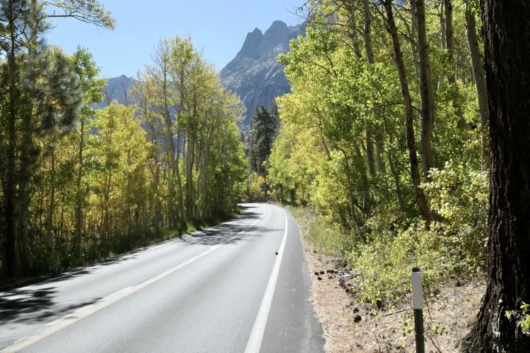
The theme of the SSC 35th Anniversary Celebration is inspired cycling and Bill embodies that in his riding and adventures and his sharing.
Bill is a talented writer and journalist as I am sure you will agree when you read his latest cycling tour adventure blog: Bill's Eastern Sierra Fall Adventure

Please log in to our new website!
If you haven't had the chance to log in to your profile on the new website. Please do so. Check out your info and set your preferences. And most important of all, upload a photo for your avatar!

Weekly Rides Update
This time of year it starts getting colder and there is less daylight to ride by, especially after work hours. Some folks turn to their indoor trainers, others put lights on their bikes and ride in groups for safety and fun. But whatever you do, don't miss a chance to get a ride in during this time of year! Keeping up your cycling, especially during the winter, keeps you feeling good and helps you avoid falling out of shape.
To help you find your cycling fix here are the weekly rides currently listed on our club calendar:
Tuesday - Taco Tuesdays
Thursday - Birria & Brews
Friday - Friday TOV
Sunday - Sunday TOV
Sunday - Gravel Adventures
Please refer to the club calendar for the details.

This message was sent to you by {Organization_Name}
If you no longer wish to receive these emails, you can unsubscribe at any time
PO Box 667, Exeter, California, 93221
{Organization_URL}

